**Leader Overview**

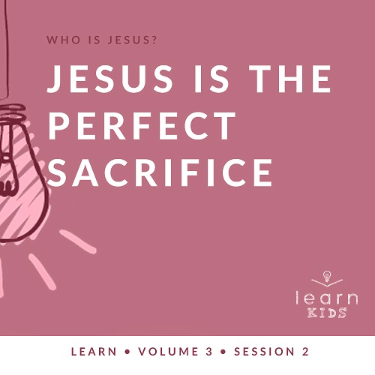

**Volume Overview**

**Who is Jesus?**

*In the classic book* Mere Christianity*, C. S. Lewis reasoned that those who refuse to believe Jesus’ claim to be God are left with the option of labeling Him as a lunatic or the devil. Jesus asked His closest followers who people thought He was (*[*Matthew 16:13*](https://ref.ly/logosref/Bible.Mt16.13)*). The disciples responded with far-ranging opinions. But then Jesus turned the question on them: “Who do you say I am?” Two thousand years later, there may not be a more important question for any of us to answer*.

**Session Overview**

**Jesus Is the Perfect Sacrifice**

*Throughout their history, we see God’s people make imperfect sacrifices to deal with the sins of the people. Jesus came to earth and lived a sinless life. His death on the Cross was the perfect sacrifice that allowed for the forgiveness of our sins. His resurrection showed that He defeated death and was victorious*.

**Bible Lesson**

Jesus’ Death on the Cross

[John 19:1–6](https://ref.ly/logosref/Bible.Jn19.1-6), [16–19](https://ref.ly/logosref/Bible.Jn19.16-19), [28–30](https://ref.ly/logosref/Bible.Jn19.28-30)

**Faith Fact**

Jesus loves the world.

**Faith Verse**

[John 3:16](https://ref.ly/logosref/Bible.Jn3.16) (NLT)

“For this is how God loved the world: He gave his one and only Son, so that everyone who believes in him will not perish but have eternal life.”

**Preparing for the Session**

**Leader Preparation Time: 20–25 Minutes**

|  |
| --- |
| ***You Will Need***  ***Large Group***  *• Bible*  *• Worship songs (Song suggestions: “Real Love” by Hillsong Young and Free; “This Is Amazing Grace” by Phil Wickham; “Good Father” by Chris Tomlin)*  *• For groups not using a phone or tablet only, add:*  *• Projector or TV*  *• Laptop*  *•* ***Faith Fact Slide***  *•* ***Faith Verse Video*** *or* ***Slide***  *•* ***Bible Lesson Video***  *•* ***Teaching Point Slides 1–3***  *• Whiteboard or large piece of paper*  *• Whiteboard marker or markers*  *• Eraser*  *• Masking tape*  *• Clear glass or vase filled with water*  *• Red food coloring*  *• Bleach*  *• Spoon*  ***Small Group***  *• Bibles for kids in your group to share*  *• Dry erase board or large piece of paper*  *• Dry erase marker or markers*  *• Eraser*  *•* ***Small Group Activity Page****, one per kid*  *• Pencils*  *To access session content and videos from a computer, visit:* [*BibleEngagementProject.com/downloads*](https://bibleengagementproject.com/Downloads) |
| ***Getting Ready***  ***Large Group***  *• Download videos and slides if needed.*  *• Select worship song(s) and have them ready to play.*  *• Read the Bible Lesson Scripture to prepare for teaching time.*  *• Tape the paper to the wall.*  ***Small Group***  *• Set up chairs in a circle, one per kid. If you can’t move chairs, then have kids sit in a circle on the floor.*  *• Print copies of the* ***Small Group Activity Page****, one per kid.*  *First time leading* Learn *for Kids? Check out the* [Facilitator Guide](https://0b769b0ed3569ef9d18b-f88d8272f61086866d50d048b43ef630.ssl.cf2.rackcdn.com/sites/biblengagementproject/Listen_Facilitator_Guide.pdf). |

**Large Group**

**30 Minutes**

*See what’s needed at the beginning of the session.*

**Introduction**

Welcome! I’m so glad you’re here! Today, we’ll learn about the most important person in the whole Bible, and His name is Jesus! Jesus did a lot of things while He was here on earth, but one of the most important things Jesus did is love people. Jesus is all about love—love for God and love for others.

**Faith Fact**

Today, we’ll talk about how much Jesus loves the whole world. He loves you, me, our friends, and people we don’t know at all. Let’s take a look at our Faith Fact and say it all together. **Jesus loves the world.**

• *Show the* ***Faith Fact Slide***.



Let’s say the Faith Fact one more time while we hold our hand over our heart. **Jesus loves the world.** Now, spin around and say it one more time. **Jesus loves the world.** Great job!

**Game**

**What Do You Love More?**

Let’s play a game to see what you love more. I’m going to read two things. If you like the first one more, stand up. If you like the second one more, stay seated. Let’s play.

• *Read this list of items and pause for kids to answer*.

• *Add more items of your own or let kids suggest some if you have time*.

1. Chick-fil-A or McDonald’s

2. Chocolate ice cream or vanilla ice cream

3. Sports or music

4. Playing games or reading a book

5. Sweet treats or salty snacks

6. Chocolate candy or sour candy

Thanks for playing that game with me. Now, let’s get ready to worship.

**Worship**

One way to worship God is by singing. Let’s worship Him together.

• *Lead the kids in singing one or two praise songs. See suggestions at the beginning of the session*.

**Bible Lesson**

I enjoyed worshipping with you. Now, let’s get ready to look at God’s Word. First, I have a question for you. What kinds of things should a person do to show love to others? *(Allow responses.)*

Those are some good ideas. When we love someone, whether they are our parents, siblings, or friends, we do special things to show them that we love them. In our story today, we’ll learn what Jesus did to show how much He loves the world. Get your Bible or pull it up on an app. As we get ready to read our Bible story, let’s pray and ask God to be with us.

**Prayer**

|  |
| --- |
| Dear God, please help us learn from Your Word today. Help us to see the love that Jesus showed to us and to learn how we can share that love with others. Amen. |

**Video Intro**

Before we look at the Bible story, let’s watch this video.

• *Play* ***Bible Lesson Video***.



**Bible Story**

**Jesus’ Death on the Cross**

That was a fun intro to our Bible story! Earlier, we shared about how we can show love to the people we care about, and your ideas were great. More than all of us together, Jesus showed love for the whole world. What kind of things has Jesus done to show love? *(Allow responses.)* Jesus’ biggest display of love was pretty amazing. Let’s check it out.

If you want to follow along with our Bible story video, open your Bible to [John 19](https://ref.ly/logosref/Bible.Jn19). We’re going to read verses [1–6](https://ref.ly/logosref/Bible.Jn19.1-6), [16–19](https://ref.ly/logosref/Bible.Jn19.16-19), and [28–30](https://ref.ly/logosref/Bible.Jn19.28-30).

• *Read the Bible story aloud to the group*.

• *In order to keep Large Group time moving along, we don’t recommend having the kids read*.

• *Optional: Remind the kids to mark this place with their Bible Bookmark, so they can read it on their own at home*.

**Teaching Time**

|  |
| --- |
| ***You Will Need***  *• Whiteboard or large piece of paper*  *• Whiteboard marker or markers*  *• Eraser*  *• Masking tape*  *• Clear glass or vase filled with water*  *• Red food coloring*  *• Bleach*  *• Spoon*  ***Getting Ready***  *• Tape the paper to the wall.* |

Wow! That’s not what I would normally think of when I imagine what it looks like to show love to someone. Normally, I might think of things like a gift, a hug, a kind word, and many of the other things we named earlier. Today, we’ll talk about how Jesus’ dying on the Cross is the greatest way He could show love to the world.

We can learn from how much Jesus loves the world. He didn’t have to show this love to us, but He did. That love is what gives all of us a chance to live forever with Him in heaven. Remember our Faith Fact, **Jesus loves the world**. Let’s say that together one more time. **Jesus loves the world**.

**1. Jesus lived a perfect life.**

• *Show the* ***Teaching Point 1 Slide***.

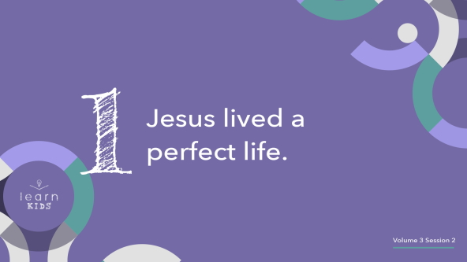

What sounds like a perfect vacation to you? *(Allow responses.)* What about the perfect afternoon snack? *(Allow responses.)* How would you explain what *perfect* means to someone? *(Allow responses.)* The idea of being perfect can be hard to fully wrap our mind around. Perfect is really important for our story today.

If something is perfect that means it’s without error. There is nothing wrong with it at all. It has no mistakes. Is anyone here perfect? *(Group response)* I didn’t think so! I know that I am definitely not perfect. Every single one of us has made a mistake sometime, and we will again in the future.

What are some mistakes that people make? *(Allow responses.)*

• *Write the mistakes on the whiteboard or large paper taped to the wall*.

• *When you’re done listing things, leave them on the board until the next section of teaching*.

The only person to ever live a fully perfect life was Jesus, God’s Son. He made no mistakes, had no sin, and was flawless. He did everything God asked Him to do, which meant that He lived the exact life that God wanted Him to live. He showed us what it looks like to live how God wants us to live our life.

**2. Jesus died for our sin.**

• *Show the* ***Teaching Point 2 Slide***.

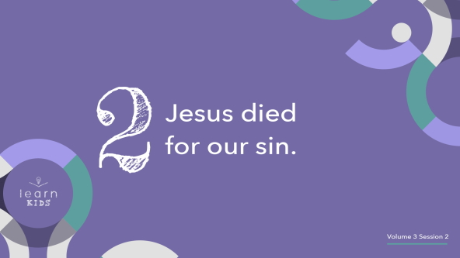

We already said that we’ve all made mistakes, right? That’s called sin. Sin is when the choices we make go against the good things that God wants us to do and has in store for our life. When God made people a long time ago, they started off without sin. God’s creation was perfect. Then, something happened that didn’t allow it to stay that way.

• *Take the glass of water*.

The first people God made, Adam and Eve, were perfect, and they lived in a perfect world. God gave them a choice to either follow His good directions on how to live or not. What did they choose? *(Group response)* They ended up choosing not to follow all of God’s instructions, which caused sin to enter the world.

• *Drop some food coloring in the water*.

They were no longer perfect. Adam and Eve lost their perfect life, their perfect home, and their perfect relationship with God. But that isn’t the end of the story. You see, God knew that each of us, just like Adam and Eve, would make mistakes and sin. God wants to be with us more than we could ever understand, and the only way we would be able to be with God forever was if someone who was perfect gave their life for our sins. God sent Jesus to live the perfect life that we can’t live for ourself. Jesus didn’t deserve to die because He never did anything wrong.

• *Pour bleach into the water glass and begin to stir it with the spoon*.

Jesus gave His life to pay for our sins. When we decide to follow Jesus, His perfection begins to wipe away the sins in our heart and life. Jesus makes us perfect in God’s eyes. Jesus died so that our sins wouldn’t be something that kept us away from God.

**3. Jesus is victorious over death.**

• *Show the* ***Teaching Point 3 Slide***.



Now, this is an amazing thing that happened, but it gets even better. Jesus not only paid for our sins with His life, but also He was victorious over death. What does that mean? It means that even though He gave up His life and died for our sins, He didn’t stay dead. How could this happen?

You know how in some video games you can get power-ups that make you invincible for a little while? Even if your character gets hit by an attack or falls off the level, you don’t lose your life for good. The reason is because things that are invincible can’t ever be defeated. It’s a pretty cool power-up to get, especially if the game you’re playing is pretty tough.

Death first began when sin came into the world. Adam and Eve were supposed to live forever with God, but after they disobeyed Him, one of their punishments was that they would have to die one day. Jesus never sinned, so He was never supposed to experience that punishment. When He did die, death had to stop and realize that Jesus had an invincibility power-up—only His was for real. He couldn’t stay dead!

Jesus was victorious over death. When we trust Him and choose to follow Him, then we get victory over death, too! Just like Adam and Eve, one day we’ll all die because of the sin in the world. Because of Jesus, we will be resurrected back to life to spend eternity with Him.

Like the mistakes we wrote on this board earlier, Jesus died for every mistake ever made. When we ask Jesus to forgive the wrong things we’ve done and accept His gift of dying for our sins *(erase the whiteboard or take the paper down and wad it up),* He takes those mistakes away from us. Jesus makes it possible for us to spend forever in heaven with God.

**Prayer and Response**

*Consider playing a worship song softly in the background while kids pray*.

Jesus loves the world so much that He gave His life for us so we could be with Him forever. Sometimes when we think about all the good God has done in our life, one of the best things we can do is thank Him for His love that He shows to us every single day. Let’s take some time to thank God for the ways that He has shown love to us.

After you thank God for what He’s done for you, ask Him to speak to you about how you can share His love with others around you. Everyone, bow your head, close your eyes, and let’s ask God to speak to us.

|  |
| --- |
| God, we open our hearts and minds to You so we can hear You today. Amen. |

• *Allow the kids to pray for a few minutes*.

Now, I want to invite you to pray with a leader about what God spoke to you or about any other need you have.

• *Pray with kids as needed*.

I really hope that you heard something from God today. If you didn’t, don’t worry. God speaks to us in many ways at different times, and hearing His voice is something we practice. Keep listening.

**Prayer**

• *Optional: Have the kids repeat phrases of the prayer after you*.

|  |
| --- |
| Dear God, thank You for loving everyone in the world, including us. Thank You for sending Jesus to die for us. We want to live like He did. Amen. |

**Faith Verse**

Our Faith Verse reminds us that God loves us so much that He sent Jesus to give us eternal life. We can gladly follow Jesus because we know He cares for us. Let’s practice our Faith Verse now.

• *Play* ***Faith Verse Video***.

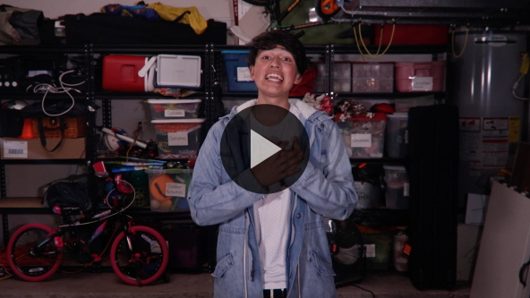

[John 3:16](https://ref.ly/logosref/Bible.Jn3.16) (NLT)

“For this is how God loved the world: He gave his one and only Son, so that everyone who believes in him will not perish but have eternal life.”

Knowing that God loves us should make it really easy for us to want to follow Jesus. When we follow Him, we know that we have hope that we will be with God forever in heaven.

**Faith Fact**

Remember our Faith Fact for today: **Jesus loves the world**. Before we go to our small groups, let’s review our Faith Fact again.

• *Show the* ***Faith Fact Slide***.



Say it with me. **Jesus loves the world.** It’s been great learning with you today.

• *Dismiss kids to Small Group time or to go home if your group time ends here*.

**Small Group**

**30 Minutes**

*This section can be done in conjunction with the large group or on its own if you do small groups with your kids. During Small Group time, the goal is to connect the kids with the Word of God and to each other. All activities are led by the small group leader.*

**Group Connection**

**Whoever Is …**

|  |
| --- |
| ***You Will Need***  *No supplies are needed.*  ***Getting Ready***  *• Set up chairs in a circle, one per kid. If you can’t move chairs, then have kids sit in a circle on the floor.* |

Sometimes, special things stick out to us about the people we love. Maybe you love your mom because she helps you when you’re hurt. Maybe you love your grandpa because he grills the best burgers. There are some pretty cool people in this circle with us today, and every single one of us deserves to be loved. Let’s play a game that can help us see some special things about each other.

Everyone will sit in the circle except the person who is It. The person who’s It will say, “I love whoever …” and then finish the sentence with something. For example, “I love whoever has pets.” If you match what the person in the middle says, you have to get up and find a new seat as fast as you can. Whoever is left without a seat leads the next round.

• *If a kid gets up, they cannot change to a seat that is directly next to them*.

• *Caution your kids to be careful to not run into each other*.

• *If only one kid stands, they automatically gets to be It*.

• *If only two kids sitting next to one another stand, they just switch seats*.

**Learn about It**

|  |
| --- |
| ***You Will Need***  *• Bibles for kids in your group to share*  *No prep needed for this activity.* |

**Scripture Search:** [**1 Corinthians 15:3–8**](https://ref.ly/logosref/Bible.1Co15.3-8)**;** [**John 3:16–17**](https://ref.ly/logosref/Bible.Jn3.16-17)**;** [**Hebrews 12:1–3**](https://ref.ly/logosref/Bible.Heb12.1-3)**;** [**Romans 12:1–2**](https://ref.ly/logosref/Bible.Ro12.1-2)

Let’s dig deeper into God’s Word and see what else He has to say to us. As we find and read each of these verses, let’s consider: What does this Scripture mean for our life today?

• *Give each kid a Bible and search for one or more of the Scriptures as a group together (as time allows). When everyone has found the Scripture, have one of the kids read it. Then, answer the questions about it*.

• *Pair kids who need additional help with older kids or start simple and look up the session’s Bible story Scripture:* [*John 19:1–6*](https://ref.ly/logosref/Bible.Jn19.1-6)*,* [*16–19*](https://ref.ly/logosref/Bible.Jn19.16-19)*,* [*28–30*](https://ref.ly/logosref/Bible.Jn19.28-30)*. Kids will get better finding Scriptures the more they practice*.

• *Optional: Make this a competition to see who can find the Scripture first*.

**Bible Reading Tip**

God’s Word is so good. Sometimes, it can be easy to be overwhelmed by all the pages, words, and stories, and we forget to slow down and let God’s Word come alive to us. Here’s a tip on how to make sure you get everything you can out of the Bible: Study verses one at a time. There’s nothing wrong with taking it slow to make sure you get all you can out of one verse. We can try it now with our Faith Verse. Let’s think about it phrase by phrase.

• *Say the Faith Verse in phrases, pausing to ask the kids to put the verse into their own words*.

[John 3:16](https://ref.ly/logosref/Bible.Jn3.16) (NLT)

“For this is how God loved the world: He gave his one and only Son, so that everyone who believes in him will not perish but have eternal life.”

**Challenge**

We just took a deep look at our Faith Verse, but I believe you can try this on your own. Here’s a challenge for you. Look up one of the verses from our Scripture Search that stuck out to you with a friend or someone in your family. Explain to them what you notice in that verse that could be a great encouragement to them.

**Faith Fact**

All of our Bible reading is a reminder to me of our Faith Fact. Turn to your neighbor and tell them **Jesus loves the world.** *(Group response)*

**Group Discussion**

*Feel free to use all or just a few questions as a jumping-off place for good discussion. Questions marked with * are designed for more conversation. Adjust the questions based on the age or maturity of your group. Typically, older kids will be able to dive a little deeper than younger ones*.

**Questions**

• *If small group activities are not immediately following large group time, you may want to read the Bible story passage before this discussion*.

What were the people shouting at the beginning of the story?

* Do you think that Pilate wanted Jesus to be crucified? Why or why not?

What was written on the sign that was placed above Jesus’ head on the cross?

What happened when Jesus was thirsty on the cross?

What did Jesus say before He died?

* Why do you think He said this?

Did Jesus deserve to die on the cross?

* How did Jesus’ death change our life?

* What does Jesus’ death show about how He loves us and the world?

* How can we love people around us with the same love Jesus has for the world?

**Prayer Requests**

*Finish group discussion by sharing prayer requests and praise reports. Keep track of your small group’s prayer requests and review them each time you meet*.

**Prayer**

*Have kids pray for each other’s prayer requests*.

**Faith Verse Review**

|  |
| --- |
| ***You Will Need***  *• Dry erase board or large piece of paper*  *• Dry erase marker or markers*  *• Eraser*  *No prep needed for this activity.* |

Our Faith Verse for today is [John 3:16](https://ref.ly/logosref/Bible.Jn3.16). It tells us that we know God loves us because He sent Jesus to give each of us eternal life. Anyone who believes in Jesus can have it. Let’s watch the Faith Verse video and do the actions together.

• *Show* ***Faith Verse Video***.



[John 3:16](https://ref.ly/logosref/Bible.Jn3.16) (NLT)

“For this is how God loved the world: He gave his one and only Son, so that everyone who believes in him will not perish but have eternal life.”

**Faith Verse Fun**

**Word Wipeout**

This verse is one of the most important verses in the whole Bible, so we’re going to try to keep in in our brain and in our heart through a game. I’m going to write out the verse on the board.

• *Write the Faith Verse large enough for everyone to see*.

Now, let’s read it together one time to keep it fresh in our mind. Pay attention because we’re about to challenge our memory.

• *Read the verse together*.

Now, we will take turns erasing words and replacing them with lines before repeating the verse. Let’s see if we can keep saying the verse as the words disappear.

• *Each time that your group recites the verse have a volunteer come up and erase one of the words from the verse. Then recite the verse again*.

• *Repeat until the whole verse is gone*.

• *If you’re short on time, consider erasing multiple words at a time or whole phrases*.

Great job, everyone! We’re learning our Faith Verse. I hope none of us ever forgets it.

**Activity Page**

**Thank You, God**

|  |
| --- |
| ***You Will Need***  *•* ***Small Group Activity Page****, one per kid*  *• Pencils*  ***Getting Ready***  *• Print copies of the* ***Small Group Activity Page****, one per kid.* |

Jesus loves the world so much. His love is the reason that we’re able to be connected to heaven and to be with God forever one day. Remember that God always wants us to feel that love from Him. He wants us to help show that love to others around us. We always have a chance to make a difference by showing Jesus’ love. Who can you tell about Jesus? *(Allow responses.)*

• *Give each kid a copy of the* ***Small Group Activity Page*** *and a pencil and let them complete the maze*.

Let’s see if you can follow the path using our Faith Verse as a reminder that we need to tell others about Jesus’ love for them.

**Dismissal**

I’ve had a great time with you finding out more about how much Jesus loves us. Let’s close in prayer.

**Prayer**

|  |
| --- |
| Dear God, thank You so much for loving us. Thank You for sending Your perfect Son to take away our sins and to show us the love we were always meant to feel and know from You. Help us to share Your love with others every day. Amen. |

**Faith Fact Recap**

• *Show the* ***Faith Fact Slide***.



One important thing I want you to remember from today is our Faith Fact. Let’s say it together one more time. **Jesus loves the world.** I’m glad you came today. I can’t wait to see you next time.

• *Send home the* ***Small Group Activity Page***.

• *Remind parents that there are* ***Family Devotions*** *available on the app to do with their kid*.

• *Tell everyone the date and time for the next session*.